Predicting Multidrug-Resistant Tuberculosis in Moldova

Alyssa Madilyn Santoso

**Introduction**

Tuberculosis (TB) remains a global health challenge, despite commendable efforts to control its incidence and mortality (WHO, 2023). One of the gravest threats to recent progress in TB control is the emergence of multidrug-resistant TB (MDR-TB), a form of TB that is resistant to essential first-line combination therapy (Jenkins, 2012). MDR-TB control is a multifaceted challenge due to timely detection through drug susceptibility testing (DST) and ensuring access to quality treatment (Jenkins, 2013). The alarming surge in MDR-TB cases worldwide has emphasized the need to improve our understanding of this drug-resistant strain.

The Republic of Moldova has borne a disproportionately high burden of MDR-TB cases compared to the rest of the world. Moldova has experienced economic challenges, resulting in a substantial emigration of its population to Europe. This demographic shift, coupled with socioeconomic hardships, has amplified the issue of MDR-TB within the country (Jenkins, 2013). Moreover, it is crucial to recognize the contextual factors that influence the prevalence of MDR-TB as it can inform resource allocation and targeted interventions.

The purpose of this study was to build a predictive model with the best performance to identify individuals at risk of MDR-TB in Moldova based on demographic and clinical variables. Specifically we investigated the performances of 3 machine learning algorithms: classification tree, random forest and gradient boost machine. We were interested in what variables these models anticipated to be the greatest predictors of developing MDR-TB.

**Methods**

Description of survey

The Moldova dataset is a study designed to assess patients diagnosed with active TB in Moldova during the years 2008 and 2009. The dataset includes information on 11,501 patients who were confirmed, through DST, not to have MDR-TB. It encompasses a wide range of patient data, including demographics, details of the TB infection, and information regarding the treatments administered. The data collection process involved both laboratory results and data obtained at the initial diagnosis. Furthermore, data was verified by the National Tuberculosis Programme and the National Centre of Health Management. The study excludes TB cases diagnosed within the penitentiary system due to inconsistencies in the reporting of follow-up test results from these patients.

Measures

An MDR-TB diagnosis is defined as a confirmation through DST of resistance to at least isoniazid and rifampicin, and non-MDR-TB cases are those with confirmed susceptibility to isoniazid and/or rifampicin. Information on patient resistance is coded yes if the TB was resistant to the drug, and no otherwise.

Age at TB diagnosis and household size were continuous variables used in this analysis. Age at diagnosis was determined using date of birth and date of diagnosis from the dataset.

Location, in which a person resides, was determined by patients' response between urban (1) or rural (2). Previous TB history treatment was determined by patient’s response using the following categories: (1) Yes, unknown drugs, (2) No, (11) Yes, I line drugs, and (12) Yes, II line drugs. I line drugs corresponding to patients who had Isoniazid (I), Rifampicin(R), Ethambutol(A) and Pyrazinamide(Z). II line drugs means patients had drugs other than I, R, A and Z. For this analysis, responses were grouped to yes or no. Gender was categorized between male and female. Citizenship was categorized between The Republic of Moldova and other. HIV testing and results was determined by the patient's response using the following categories: Positive, Negative and Unknown. Occupation was categorized as disabled, pensioner, student, unemployed and worker. Salaried was used to determine whether an individual received an annual salary, categorized to yes or no. Type of TB was categorized as the following: (1) never before had (new case), (2) previously had TB but had TB in the body outside the lungs and are now relapsing, (3) previously had TB but stopped treatment early and are now resuming treatment again, (4) previous treatment they had wasn't working (this can happen if someone has undiagnosed drug resistance or has other comorbidities which make it harder for them to do well on treatment), (5) chronic TB, (6) started treatment abroad and so details of previous TB episodes are unknown, (21) previously had TB but were smear negative and are now relapsing, (22) previously had TB but were smear positive and are now relapsing.

Statistical analysis

We conducted an exploratory data analysis to determine skewness, distribution, outliers, and to understand proportions. To further explore the relationships between the categorical variables, a chi-squared analysis between all the variables was performed. This analysis also aided in variable selection. The data was divided equally between the training and testing datasets. The data was used to train and test a classification tree model, random forest model and gradient boost machine model. Finally, the performance of these three predictive models for MDR-TB diagnosis is assessed based on confusion matrices and associated statistics such as ROC, sensitivity and specificity to determine which model is most appropriate for predicting MDR-TB in Moldova.

**Results**

There were 11,501 data on patients who were confirmed, through DST, not to have MDR-TB. There is a significant proportion of patients who are resistant to treatment (14.7%), while the majority have not undergone previous treatment (68.8%). Geographically, the dataset encompasses a mix of rural (47.1%) and urban (52.9%) locations. The HIV testing results indicate a predominant negative status (73.2%). The vast majority of patients hold Moldovan citizenship (99.6%), and there is a male predominance (73.9%) in the gender distribution. Occupational diversity is evident, with a substantial portion of the population being unemployed (62.8%). Moreover, there is a significant number who are not salaried (69.2%). The types of tuberculosis vary, with those who have never had TB (new cases) being the most prevalent (68.0%) and the least being those who started treatment abroad and so details of previous TB episodes are unknown being the least cases (0.548%) (Figure 5 and Figure 3). For the continuous variables, household size and age at diagnosis, there is a negative weak linear relationship (r=-0.12) among these predictors based on the pairwise correlations making collinearity unlikely (Figure 1). Furthermore, household size was skewed to the right while age at diagnosis is approximately symmetrical, with skewness values of 2.14 and 0.17, respectively. Figure 2 is a boxplot of variables household size and age at diagnosis, showing great outliers in household size. The chi-squared analysis revealed that all variables, except citizenship, exhibit significant associations with resistance status (Figure 4). Though location and resistance status does not show significant association, previous studies have concluded otherwise as location could determine accessibility to clinics or hospitals.

The performance of these three predictive models for MDR-TB diagnosis is assessed based on confusion matrices and associated statistics. The classification tree model achieved an accuracy of 85.83%, with a notably low sensitivity of 5.45% and high sensitivity of 99.3% on the training dataset (Figure 6). The random forest model demonstrated improved sensitivity at 19.09% and sensitivity of 96.0% while maintaining a high accuracy of 85.01% on the training dataset (Figure 7). This model predicted the variable age at diagnosis to have the most predictive power of developing MDR-TB and HIV test to have the least predictive power (Figure 8). The gradient boost machine model exhibited a sensitivity of 0%, indicating potential challenges in identifying positive cases on the training dataset (Figure 9). However, the model achieved a high specificity of 99.9% and accuracy of 85.7%. This model predicted the variable type of TB to have the most predictive power of developing MDR-TB and occupation to have the lowest influence in predicting (Figure 10). Figure 11 is a summary of statistics from a resampling procedure to assess the model performances on the training data. The gradient boost machine model achieved the highest mean ROC of 73.3% (Figure 12) and specificity of 99.9%, but has the lowest sensitivity among the models on the training dataset. The random forest model achieved the highest sensitivity of 13.1% on the training set.

**Discussion**

This study aimed to build the best model for predicting whether an individual in Moldova will develop MDR-TB based on demographic and clinical variables. The results from the analyses of confusion matrices and associated statistics indicate that random forest is the best model in predicting MDR-TB cases in Moldova. On the training dataset, the model achieved the highest sensitivity among the 3 models, but comparable results on ROC and specificity values. On the testing dataset, the model achieved an overall accuracy of 85.01% on the test dataset, and demonstrated a sensitivity of 19.09%, indicating its ability to correctly identify resistant cases, while maintaining a high specificity of 96.04%, suggesting proficiency in recognizing non-resistant cases. The model's balanced accuracy stands at 57.57%, indicating a reasonable balance between sensitivity and specificity in predicting resistance status. This model predicted age at diagnosis to have the most predictive power and HIV test results to be the lowest predictive power. Though random forest achieved a moderate discriminatory power based on its ROC value, it is important to note that this study chose to prioritize the model’s ability to identify true positive rate as a crucial metric– and in this context would be the model's ability to correctly identify individuals with MDR-TB. The emphasis on sensitivity is justified in the context of MDR-TB, where early and accurate detection of positive cases is crucial for effective treatment and prevention of further transmission.

The random forest model identified the variable age at diagnosis as the most influential variable in determining the likelihood of MDR-TB. This indicates that among the considered factors, the age at which individuals are diagnosed with TB carries the highest weight in the model's ability to accurately predict MDR-TB cases. The importance of age at diagnosis emphasizes its significance in predicting the risk of MDR-TB development. This finding implies that healthcare professionals and policymakers should take into account the patient’s age when developing interventions or preventive measures, as individuals diagnosed at different ages may exhibit varying susceptibilities to multi-drug resistance.

**Conclusion**

This study built the best predictive model for identifying MDR-TB cases in Moldova. The results from this study suggests that random forest is the best algorithm to use because it is adept at correctly identifying individuals with MDR-TB, which minimizes the risk of false negatives and ensures that those who need treatment are appropriately identified. The relevance of this study extends to practical applications where healthcare providers can apply the model to improve screening processes, develop appropriate interventions, and allocate resources efficiently. By identifying key predictors, such as age at diagnosis, this gives valuable insights to what factors contribute to MDR-TB, which aids in developing appropriate interventions that could target more vulnerable populations.

Though the predictive models developed in this study demonstrated good performance on the training data, it needs validation on independent datasets to assess its generalizability and robustness. The models' effectiveness in different populations or settings should be explored further in future research and validation studies. These findings have important implications for public health interventions and targeted efforts in combating the spread of MDR-TB. Future research should continue to explore additional factors that may contribute to MDR-TB.

**References**

WHO. (2023, April 21). *Tuberculosis (TB)*. World Health Organization. https://www.who.int/news-room/fact-sheets/detail/tuberculosis#:~:text=Multidrug%2Dresistant%20TB%20(MDR%2D,treatment%20between%202000%20and%202021.

Jenkins, H. E., Plesca, V., Ciobanu, A., Crudu, V., Galusca, I., Soltan, V., Serbulenco, A., Zignol, M., Dadu, A., Dara, M., & Cohen, T. (2012). Assessing spatial heterogeneity of multidrug-resistant tuberculosis in a high-burden country. *European Respiratory Journal*, *42*(5), 1291–1301. https://doi.org/10.1183/09031936.00111812

Jenkins, H. E., Crudu, V., Soltan, V., Ciobanu, A., Domente, L., & Cohen, T. (2014). High risk and rapid appearance of multidrug resistance during tuberculosis treatment in Moldova. *European Respiratory Journal*, *43*(4), 1132–1141. https://doi.org/10.1183/09031936.00203613

Jenkins, H. E., Ciobanu, A., Plesca, V., Crudu, V., Galusca, I., Soltan, V., & Cohen, T. (2013). Risk factors and timing of default from treatment for non-multidrug-resistant tuberculosis in Moldova. *The International Journal of Tuberculosis and Lung Disease*, *17*(3), 373–380. https://doi.org/10.5588/ijtld.12.0464

Admassu, F., Abera, E., Gizachew, A., Sedoro, T., & Gari, T. (2023). Risk factors of multidrug resistant tuberculosis among patients with tuberculosis at selected multidrug resistance treatment initiative centres in southern Ethiopia: A case-control study. *BMJ Open*, *13*(1). https://doi.org/10.1136/bmjopen-2022-061836

**Appendix**

**Figure 1.** Pairwise correlation matrix comparing household size and age at diagnosis. 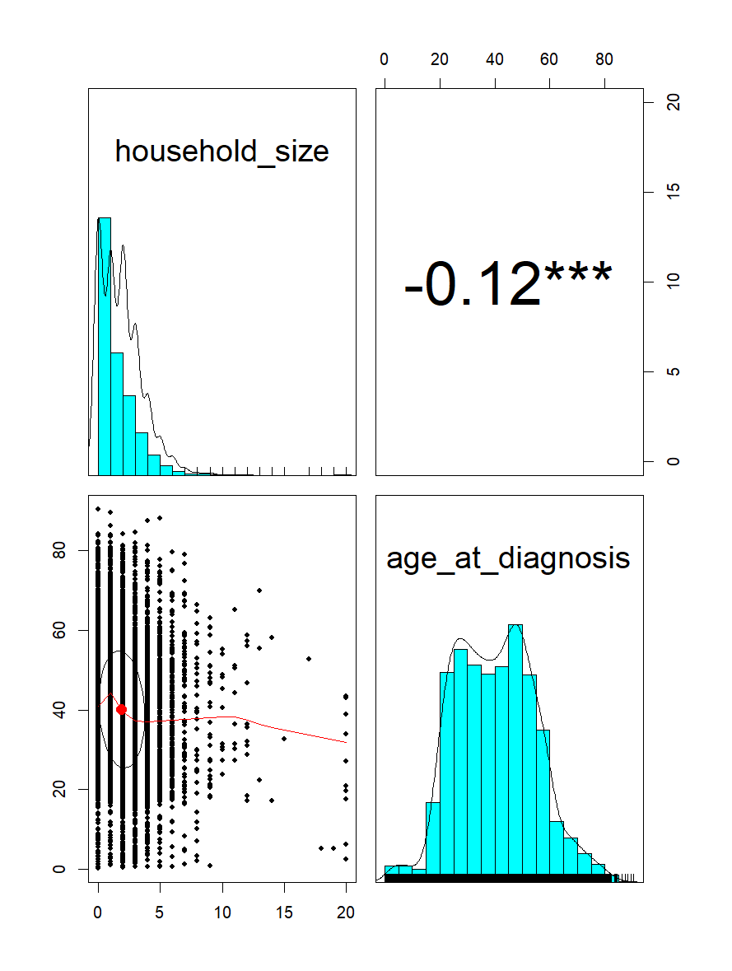

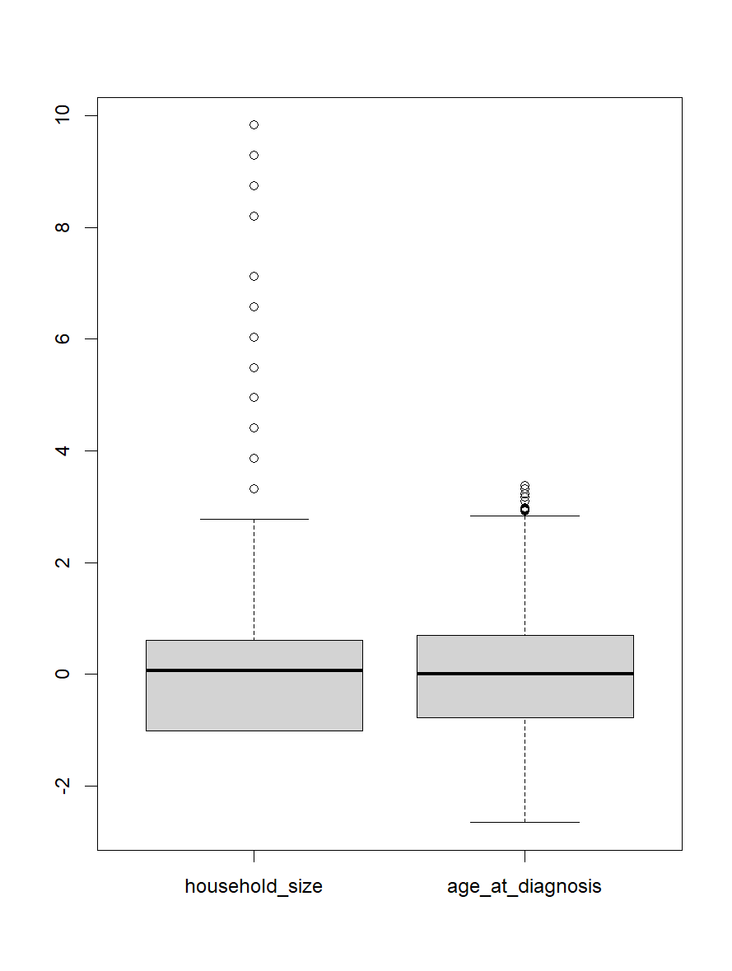

**Figure 2.** Boxplot graph comparing distribution of household size and age at diagnosis.

**Figure 3.** Statistic summary of categorical variables used in analysis: resistance, previous history of TB treatment, location (urban vs. rural), HIV test (negative, positive unknown), citizenship (Moldova vs. other), gender (female vs. male), occupation (disabled, pensioner, student, unemployed, worker), salaried (yes vs. no), type of TB ((1) never before had, (2) previously had TB but had TB in the body outside the lungs and are now relapsing, (3) previously had TB but stopped treatment early and are now resuming treatment again, (4) previous treatment they had wasn't working (this can happen if someone has undiagnosed drug resistance or has other co-morbidities which make it harder for them to do well on treatment), (5) chronic TB, (6) started treatment abroad and so details of previous TB episodes are unknown, (21) previously had TB but were smear negative and are now relapsing, (22) previously had TB but were smear positive and are now relapsing)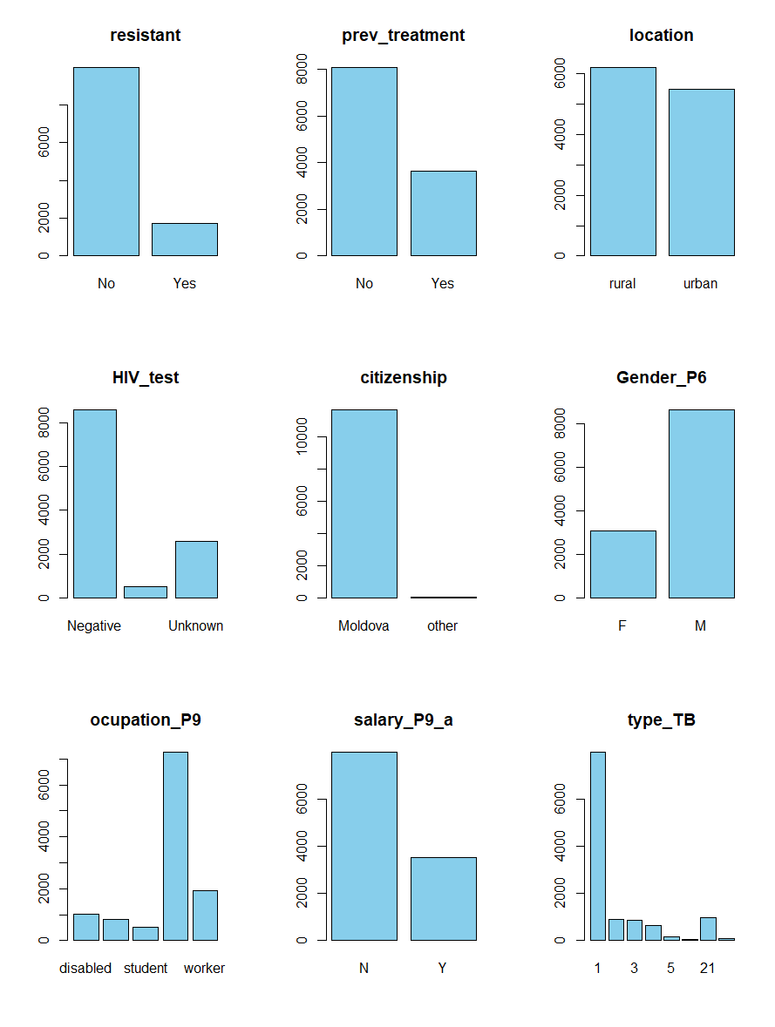

| **Variables** | **X-squared** | **p-value** |
| --- | --- | --- |
| Previous TB Treatment | 818.52 | < 2.2e-16 |
| Location | 23.673 | 1.142e-06 |
| HIV test result | 66.296 | 4.019e-15 |
| Citizenship | 0.0030036 | 0.9563 |
| Gender | 59.936 | 9.802e-15 |
| Occupation | 108.93 | < 2.2e-16 |
| Salary | 45.692 | 1.384e-11 |
| Type of TB | 1209.9 | < 2.2e-16 |

**Figure 4.** Summary of Chi-squared test between categorical variables: previous TB treatment, location, HIV test result, citizenship, gender, occupation, salary, type of TB. Statistical significance is determined by p-value<0.05.

| **Variable** | **Categories** | **Frequency N (%)** |
| --- | --- | --- |
|  |  | **N = 11, 501** |
| Gender | F  M | 3004 (26.1%)  8497 (73.9%) |
| Citizenship | Moldova  Other | 11450 (99.6%)  51 (0.43%) |
| Occupation | disabled  pensioner  student  unemployed  worker | 1021 (8.88%)  818 (7.11%)  507 (4.41%)  7222 (62.8%)  1933 (16.8%) |
| Salaried | N  Y | 7963 (69.2%)  3538 (30.8%) |
| location | Urban  Rural | 5421(52.9%)  6080 (47.1%) |
| HIV Test Result | Negative  Positive  Unknown | 8425 (73.2%)  540 (4.70%)  2536 (22.1%) |
| Type of TB | 1  2  3  4  5  6  21  22 | 7817 (68.0%)  907 (7.89%)  846 (7.36%)  649 (5.64%)  170 (1.48%)  63 (0.548%)  964 (8.38%)  85 (0.739%) |
| Previous TB Treatment | N  Y | 7916 (68.8%)  3585 (31.2%) |
| Resistant | N  Y | 9807 (85.3%)  1694 (14.7%) |

**Figure 5.** Statistic summary showing frequency and column percentages of categorical variables used in analysis: resistance, previous history of TB treatment, location (urban vs. rural), HIV test (negative, positive unknown), citizenship (Moldova vs. other), gender (female vs. male), occupation (disabled, pensioner, student, unemployed, worker), salaried (yes vs. no), type of TB ((1) never before had, (2) previously had TB but had TB in the body outside the lungs and are now relapsing, (3) previously had TB but stopped treatment early and are now resuming treatment again, (4) previous treatment they had wasn't working (this can happen if someone has undiagnosed drug resistance or has other co-morbidities which make it harder for them to do well on treatment), (5) chronic TB, (6) started treatment abroad and so details of previous TB episodes are unknown, (21) previously had TB but were smear negative and are now relapsing, (22) previously had TB but were smear positive and are now relapsing)

Confusion Matrix and Statistics

Reference

Prediction Yes No

Yes 18 14

No 312 1957

Accuracy : 0.8583

95% CI : (0.8434, 0.8723)

No Information Rate : 0.8566

P-Value [Acc > NIR] : 0.4202

Kappa : 0.076

Mcnemar's Test P-Value : <2e-16

Sensitivity : 0.054545

Specificity : 0.992897

Pos Pred Value : 0.562500

Neg Pred Value : 0.862494

Prevalence : 0.143416

Detection Rate : 0.007823

Detection Prevalence : 0.013907

Balanced Accuracy : 0.523721

'Positive' Class : Yes

**Figure 6.** Result of confusion matrix of classification tree model on training dataset. Achieved accuracy of 85.8%, sensitivity of 5.5%, specificity of 99.3%.

Confusion Matrix and Statistics

Reference

Prediction Yes No

Yes 63 78

No 267 1893

Accuracy : 0.8501

95% CI : (0.8348, 0.8644)

No Information Rate : 0.8566

P-Value [Acc > NIR] : 0.822

Kappa : 0.1987

Mcnemar's Test P-Value : <2e-16

Sensitivity : 0.19091

Specificity : 0.96043

Pos Pred Value : 0.44681

Neg Pred Value : 0.87639

Prevalence : 0.14342

Detection Rate : 0.02738

Detection Prevalence : 0.06128

Balanced Accuracy : 0.57567

'Positive' Class : Yes

**Figure 7.** Result of confusion matrix of random forest model on training dataset. Achieved accuracy of 85.0%, sensitivity of 19.1%, specificity of 96.0%.

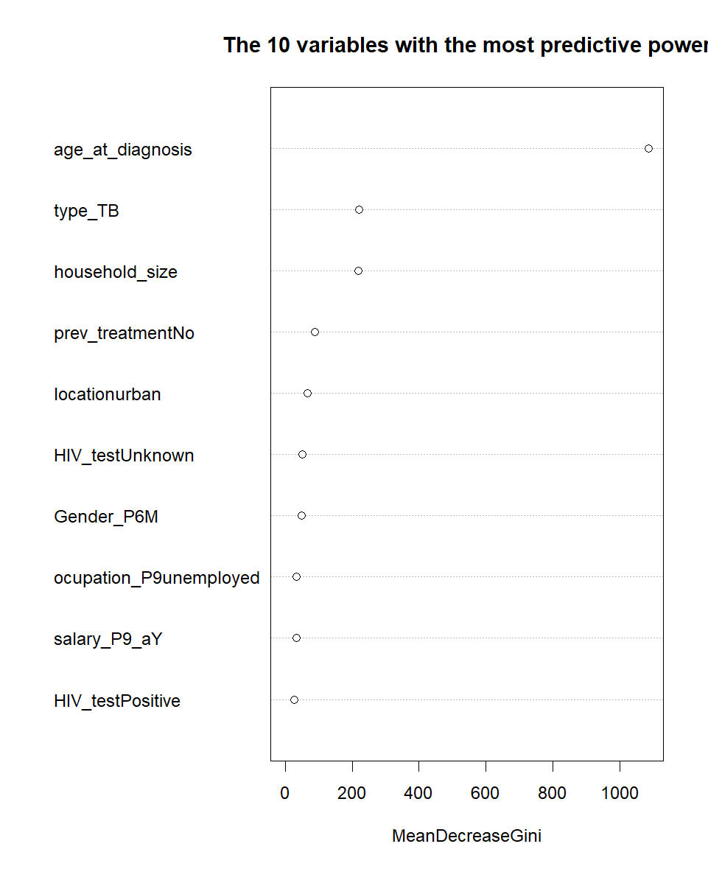

**Figure 8.** Plot of variables with the most predicted power, predicted by random forest model.

Confusion Matrix and Statistics

Reference

Prediction Yes No

Yes 0 1

No 330 1970

Accuracy : 0.8561

95% CI : (0.8411, 0.8702)

No Information Rate : 0.8566

P-Value [Acc > NIR] : 0.5383

Kappa : -9e-04

Mcnemar's Test P-Value : <2e-16

Sensitivity : 0.0000000

Specificity : 0.9994926

Pos Pred Value : 0.0000000

Neg Pred Value : 0.8565217

Prevalence : 0.1434159

Detection Rate : 0.0000000

Detection Prevalence : 0.0004346

Balanced Accuracy : 0.4997463

'Positive' Class : Yes

**Figure 9.** Result of confusion matrix of gradient boost machine model on training dataset, Achieved accuracy of 85.6%, sensitivity of 0.0%, specificity of 99.9%.

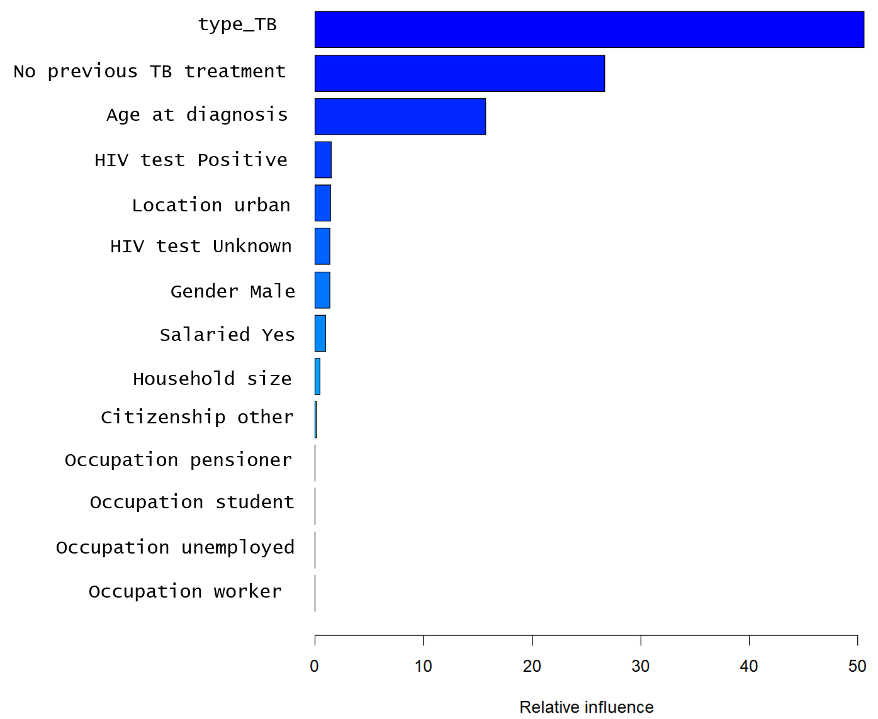

**Figure 10.** Plot of variables with the most predicted power, predicted by gradient boost machine model.

Call:

summary.resamples(object = results)

Models: rf, gbm, trees

Number of resamples: 10

ROC

Min. 1st Qu. Median Mean 3rd Qu. Max. NA's

rf 0.6592762 0.6671953 0.6807291 0.6825237 0.6946912 0.7174604 0

gbm 0.6850654 0.7209110 0.7332205 0.7335005 0.7491448 0.7660323 0

trees 0.6662431 0.6736166 0.6830490 0.6890852 0.7003416 0.7395146 0

Sens

Min. 1st Qu. Median Mean 3rd Qu. Max. NA's

rf 0.08823529 0.10661765 0.131843066 0.131220481 0.150480356 0.18382353 0

gbm 0.00000000 0.00000000 0.003649635 0.005130957 0.007352941 0.01470588 0

trees 0.03676471 0.09124088 0.109891584 0.098223486 0.115164770 0.14705882 0

Spec

Min. 1st Qu. Median Mean 3rd Qu. Max. NA's

rf 0.9502551 0.9550248 0.9604331 0.9590362 0.9626559 0.9642857 0

gbm 0.9961735 0.9987233 0.9993622 0.9989794 1.0000000 1.0000000 0

trees 0.9668367 0.9735250 0.9763729 0.9785597 0.9802113 0.9936224 0

**Figure 11.** Summary statistics, assessing model performance on training dataset. This summary compared the ROC, sensitivity and specificity of classification tree, random forest and gradient boost machine.

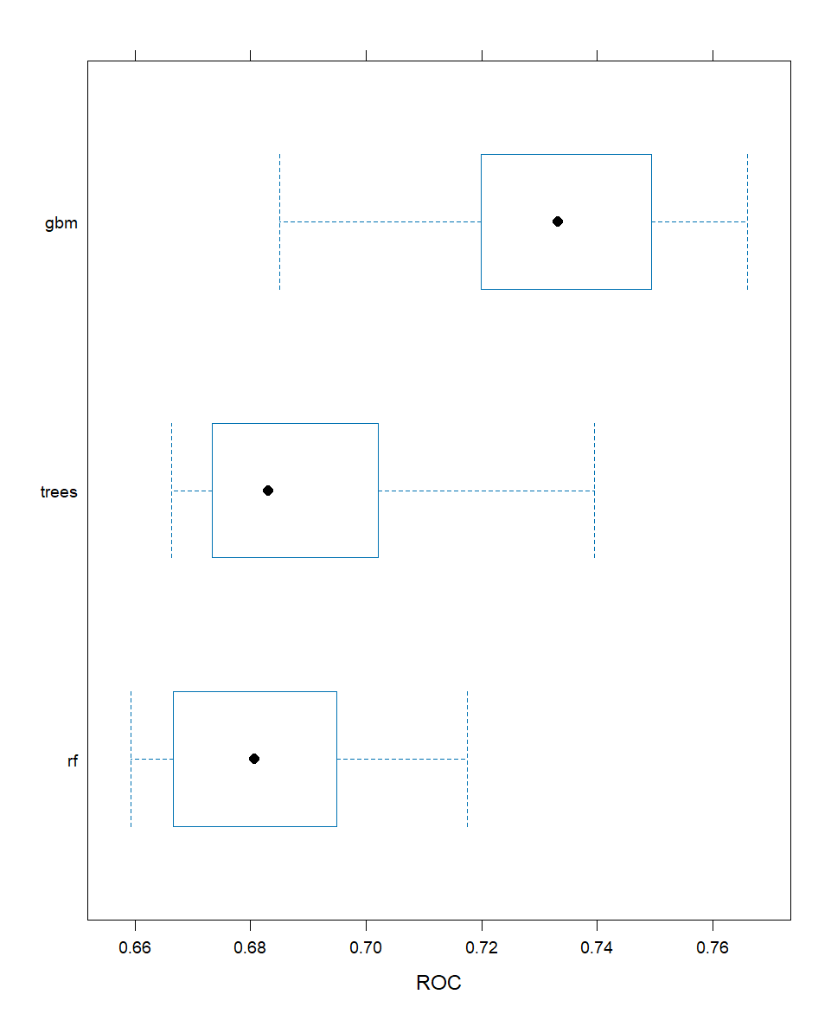

**Figure 12.** Boxplot to compare ROC values of classification tree, random forest and gradient boost machine models.

**Code:**

library(readxl)

library(dplyr)

library(writexl)

library(moments)

library(psych)

library(car)

library(ggplot2)

library(ISLR2)

library(randomForest)

library(caret)

library(gbm)

library(purrr)

moldova <- read_excel("C:\\Users\\alyss\\OneDrive\\Desktop\\ILE\\Moldova_data.xlsx", col_names = TRUE)

head(moldova)

# Data cleaning

# Variables chosen to use:

# Continuous Data: household_size, age_at_diagnosis

# Categorical Data: prev_treatment, location, HIV_test , citizenship, Gender_P6, ocupation_P9, salary_P9_a, type_TB

# outcome variable: resistant (yes/no)

# Make variable resistant= yes/no (1/0)

moldova$resistant <- ifelse(moldova$P21_H == TRUE & moldova$P21_R == TRUE, "Yes", "No")

moldova$resistant <- factor(moldova$resistant, levels = c("Yes", "No"))

# Make variable prev_treatment= Yes/No using P23

moldova$prev_treatment <- ifelse(moldova$P23 == 2, "No", "Yes")

moldova$prev_treatment <- factor(moldova$prev_treatment, levels = c("Yes", "No"))

#rename urban-rural_P5_c

moldova <- moldova %>%

rename(location = `urban-rural_P5_c`)

#rename p24

moldova <- moldova %>%

rename(type_TB = P24)

#rename p13

moldova <- moldova %>%

rename(household_size = P13)

# Make variable HIV_test= Positive/Negative/Unknown

moldova$HIV_test <- ifelse(moldova$aP28 == 2, "Positive",

ifelse(moldova$aP28 == 3, "Negative", "Unknown"))

#age_at_diagnosis variable

moldova <- moldova %>%

mutate(age_at_diagnosis = as.numeric(difftime(P14, birth_day, units = "days")) / 365.25)

selected_variables <- c("household_size", "age_at_diagnosis", "resistant", "prev_treatment", "location", "HIV_test",

"citizenship", "Gender_P6", "ocupation_P9", "salary_P9_a", "type_TB")

moldova2 <- subset(moldova, select=selected_variables)

moldova2 <- na.omit(moldova2) # omit NA rows

# Explanatory Data Analysis

# For Continuous Variables

# Check normality and outliers

# Check distribution

moldova2[,c("household_size", "age_at_diagnosis")] %>% pairs.panels(star=T)

# Check outliers using boxplot

lapply(moldova2[,c("household_size", "age_at_diagnosis")],scale) %>%

boxplot()

# Check skewness for normality

skewness(moldova2[,c("household_size", "age_at_diagnosis")])

# examine frequency counts for categorical and discrete variables

categorical_vars <- c("resistant", "prev_treatment", "location", "HIV_test",

"citizenship", "Gender_P6", "ocupation_P9", "salary_P9_a", "type_TB")

lapply(moldova2[categorical_vars], table) # Contingency table

prop_table <- list() # proportions table

for (var in categorical_vars) {

prop <- prop.table(table(moldova2[[var]]))*100

prop_table[[var]] <- prop

}

prop_table

# bar chart

par(mfrow = c(3, 3)) # 3 rows, 3 columns

for (var in categorical_vars) {

bar_chart <- barplot(table(moldova2[[var]]), main = var, col = "skyblue")

print(bar_chart)

}

# chi squared analysis

# Perform chi-squared test for each pair of categorical variables

for (var1 in categorical_vars) {

for (var2 in setdiff(categorical_vars, var1)) {

contingency_table <- table(moldova2[[var1]], moldova2[[var2]])

chi_squared_result <- chisq.test(contingency_table)

cat("Chi-Squared Test between", var1, "and", var2, ":\n")

print(chi_squared_result)

cat("\n")

}

}

# Use classification trees, random forests, gradient boost machine to compare models

set.seed(123)

sampling_index <- sample(1:nrow(moldova2), 0.8 * nrow(moldova2))

train <- moldova2[sampling_index, ]

test <- moldova2[-sampling_index, ]

control <- trainControl(method="cv",

number = 10,

classProbs = TRUE,

summaryFunction =twoClassSummary,

savePredictions = 'all')

### model 1: classification trees

model_trees <- train(resistant ~.,

data = train,

method = "rpart",

metric = 'ROC',

trControl = control)

model_trees

# prediction on test dataset

pred_trees <- predict(model_trees, test)

cm_trees <- confusionMatrix(pred_trees, test$resistant)

cm_trees

### model 2: random forest

model_rf <- train(resistant ~.,

data = train,

method = "rf",

metric = 'ROC',

trControl = control)

model_rf

# prediction on test dataset

pred_rf <- predict(model_rf, test)

cm_rf <- confusionMatrix(pred_rf, test$resistant)

cm_rf

varImpPlot(model_rf$finalModel, sort = TRUE, n.var = 10, main = "The 10 variables with the most predictive power")

### model 3: gradient boost machine

model_gbm <- train(resistant ~.,

data = train,

method = "gbm",

metric = 'ROC',

trControl = control)

#prediction on test dataset

pred_gbm <- predict(model_gbm, test)

cm_gbm <- confusionMatrix(pred_gbm, test$resistant)

cm_gbm

summary(model_gbm$finalModel)

### Model Comparison

model_list <- list(rf = model_rf, gbm=model_gbm, trees=model_trees)

results <- resamples(model_list)

summary(results)

bwplot(results, metric = "ROC")

cm_list <- list(cm_rf = cm_rf, cm_gbm=cm_gbm, cm_trees=cm_trees)

results <- map_df(cm_list, function(x) x$byClass)

row.names(results) <- names(cm_list)

summary(results)